Maze Runner Report

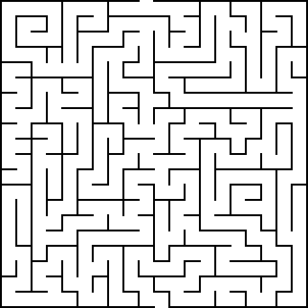CS 520 Assignment-1

# Haotian Xu(hx105), Chaoji Zuo(cz296), Xuenan Wang(xw336)

# Spring 2019

Maze Runner Report

CS 520 Assignment-1

# 1. Environments and Algorithms

Generate a maze of **10×10**, probability *p* is **0.2** and try to find escape way by following algorithms:

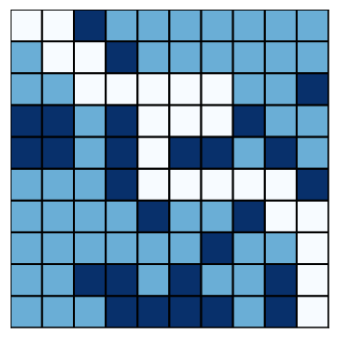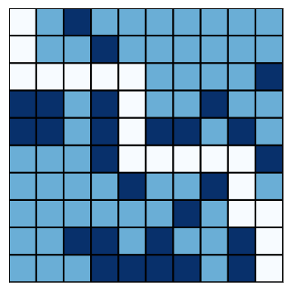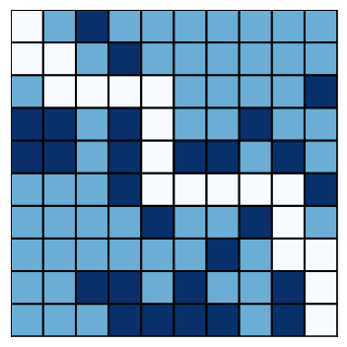

Figure 1.1 Deep-First Search Algorithm & Breadth-First Search Algorithm

Figure 1.2 A-star Algorithm(Euclidean Distance) & A-star Algorithm(Manhattan Distance)

|  | Running Time(unit: second) | Operations |
| --- | --- | --- |
| DFS | 0.060016 | 47 |
| BFS | 0.083329 | 858 |
| A-star Euclidean | 0.059519 | 292 |
| A-star Manhattan | 0.059880 | 247 |

Table 1.1 Algorithms Comparison

# 2. Analysis and Comparison

1. We tested different map sizes for 2000 rounds and found that the map size would hardly influence the solvability. The result is in Table 2.1. However, the solving time would increase a lot as the map size enlarge. Therefore, we pic 10 as our map size. It is big enough and would not take mach time to solve.

|  | Running time(unit: second) | Solvability |
| --- | --- | --- |
| Dim = 5 | 0.248 | 0.909 |
| Dim = 10 | 1.131 | 0.898 |
| Dim = 20 | 4.289 | 0.8965 |
| Dim = 50 | 24.074 | 0.882 |

Table 2.1 Map sizes comparison

1. Our paths are showed in part 1. The white blocks are the path, the light blue blocks are free blocks, the dark blue blocks are wall.
2. We set the p from range 0 to 0.7, and run each p for 2000 times. Then got a curve graph of density vs solvability. Figure 2.1 shows our result

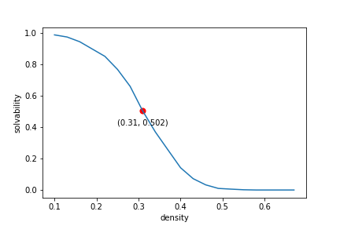

Figure 2.1 density vs solvability

As you can see, when p larger than 0.3, most mazes would be unsolvable. When p less than 0.3, most mazes would be solvable. So we thought the p0 should be 0.3. To find p0, we used DFS algorithm because it runs fast.

1. We used A* and BFS to plot density vs expected shortest path length. Because these algorithms can always find the shortest path. The results are showed in picture 2.2

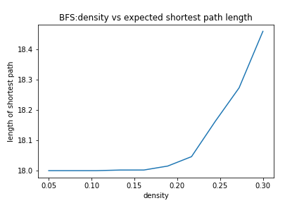

Figure 2.2 density vs expected shortest path length (BFS)

1. We thought the A*-Manhattan would perform better than A*-Euclidean in maze solving. Because A*-Manhattan would expand less nodes, so it would take less time and space. And we think the reason is the Manhattan distance can precisely calculate the smallest distance between two nodes in our maze. Figure 2.3 shows our comparison.

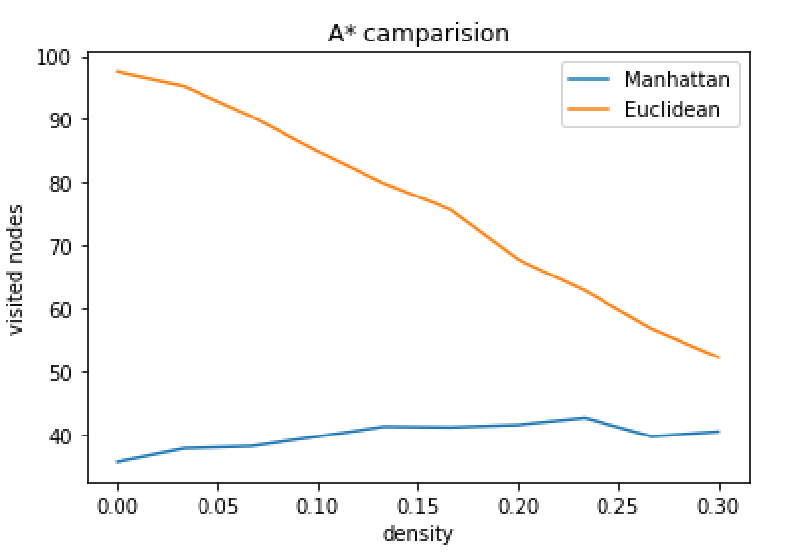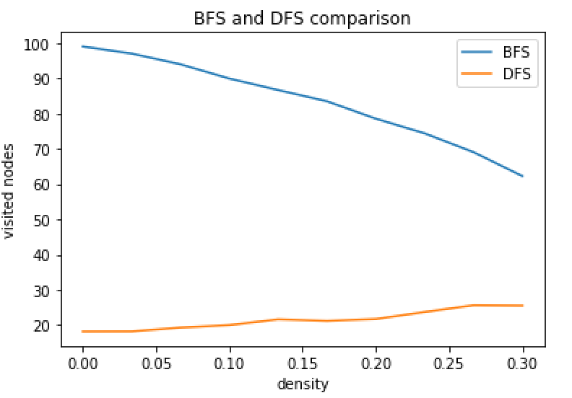

Figure 2.3 average visited nodes vs density of 4 algorithms

1. BFS would always generate an optimal shortest path in this case. But it has another shortcoming, like A*-Euclidean, it would always visit much more nodes than DFS. The result is showed in Figure 2.3.
2. These algorithms behave as they should.
3. The direction counts a lot for DFS to find a shorter path. The right and down directions should have a higher priority than left and up directions. We built two DFS algorithms and calculate their average path length. The result is showed in Figure 2.4. As you can see, the good DFS’s path would be much shorter than bad DFS, they have a huge difference.
4. bonus: we think with the n increase, the p0 would increase, but just increase a little.

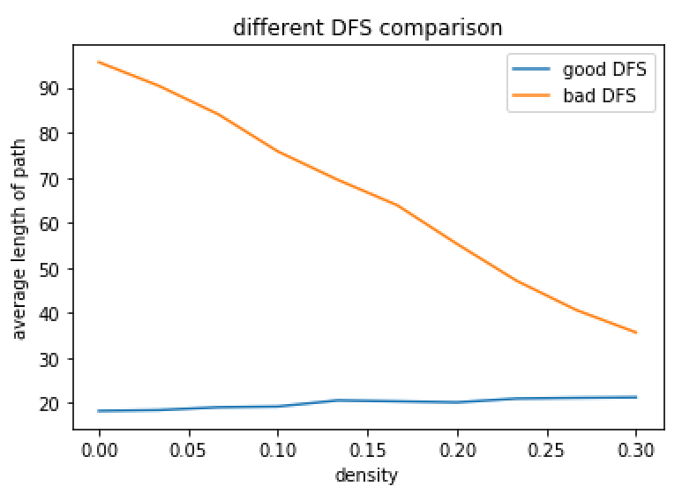

Figure 2.4 different DFS comparison

# 3. Generating Hard Mazes

In this problem, we pick Genetic algorithm to make a normal maze as hard as possible. And our goal state of each local search is a much longer shortest path.

Here is the main processes of our hard maze generating:

1. Generate a normal maze. Put the maze into a modified A*-Manhattan search algorithm.
2. Every 5 steps, stop, and save the nodes that had been visited, include free blocks and walls. This process can be regarded as inherit.
3. Shuffle the other blocks randomly, and use a normal A*-Manhattan to calculate the new shortest path. If the path is longer than the original one, save the new state of path. This process can be regarded as mutation.
4. Repeat process II and III until get the goal.

Our algorithm got a quite great result. Figure 3.1 shows an original maze compare to its final evaluated maze.

Figure 3.1 original maze compare to its final evaluated maze

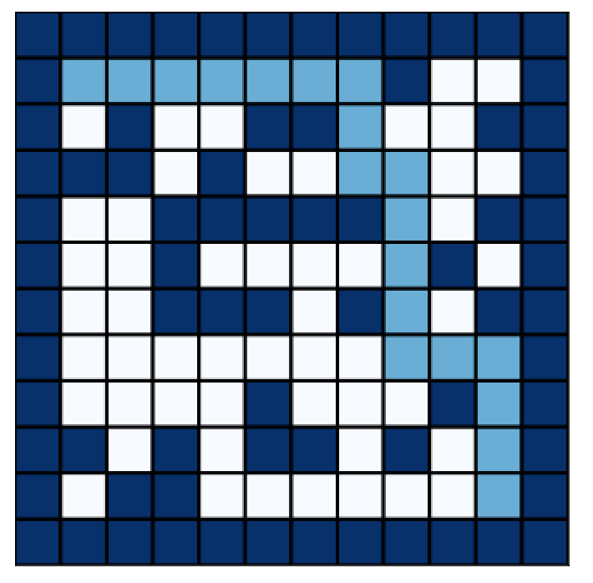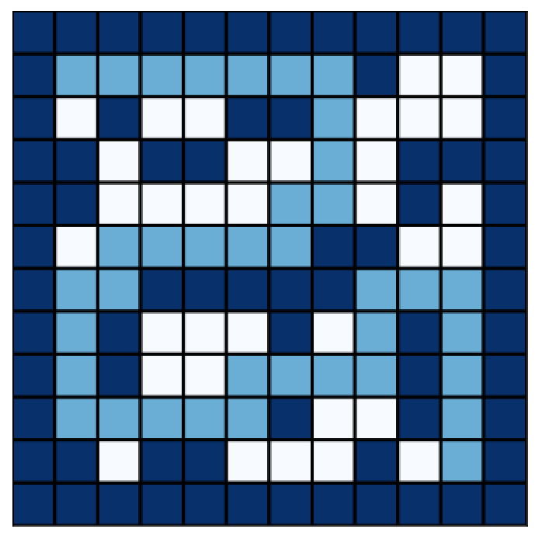

Our algorithm also can use other paired metric, and the result would not have a big difference. We thought our results agree with our intuition.

# 4. Thinning A*

* For this problem, we want to have the a more optimal heuristic for A*; therefore, we need to calculate the kind of actual distance for each state reaching the goal state in a different version of the maze.

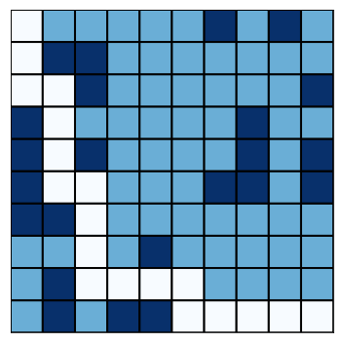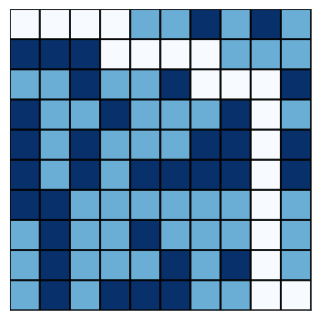

* For a given maze (10x10, with probability 0.3 for generating walls), we will strip out a fraction of blocks (in this case, strip 30% walls). Then we run BFS or DFS or even another A* search on this simplified maze. We will get a better heuristic by running the simplified maze. Left is original maze, and right one is simplified version.

Figure 4.1 origin image vs simplified image

* More thought on problem 4:
  + Using DFS to provide new heuristics: DFS has a better space complexity than BFS, which will be easy to compute the heuristics. However, DFS cannot guarantee to provide the optimal solution; in this case, DFS may generate some inadmissible heuristics.
  + Using BFS to provide new heuristics: BFS will guarantee to have optimal solution, but its space complexity is worse than DFS, which means it will not be efficient to calculate the new heuristics.
  + Using A* to provide new heuristics: A* takes advantages from both BFS and DFS, but it is a little bit weird, because we using A* to find the heuristics, and heuristics comes from the result we run A*. I just feel a little bit awkward for using the solution to answer the same problem once more.
  + Using bi-direction A*: Run an A* function which has two start nodes ( start states and goal states), start -> goal and goal -> start. There will be two fringes. When we pop those fringes, if we ends with the same state, return the path list.
  + Using hashMap with A*: when we run the A* function, we use a recursion inside the A*, then we can be bottom-to-root, memorizing the optimal heuristics for each state. In that way, we might reduce the node expansions.

# 5. What if the maze were on fire? (Bonus)

**Idea 1:**

* + - * Using a expect-max tree to find out the path that makes the robot survive and escape from the fire maze.
      * First, generating the probability of turning to be fire for each state (x, y). If there is only one fire spot near a point, the point will have 1 - (1/2) ^ (n) probability of being fire in the next round, n represent the number of fire around the point.
      * The probability will distribute the fire spot and decrease its value as we leave from the original fire place.
      * We consider this fire maze as a Game, which will have a penalty of -100 when the robot reach a fire spot and a award of 500( it may vary because of the size of the maze) for escaping from the maze. Moreover, for each decision the robot makes, there will be a constant cost -1 for moving.
      * Based on those information, if we run the expected-max tree, the algorithm should give us the optimal solution, which is the shortest path for escaping from the fire and getting out from the maze.
      * The expected-max tree will be huge, if we have a large maze. Therefore, we make some change about the algorithm. When we reach a certain state, we use BFS to find out the short path for the state's neighbors for reaching a fire or reaching the goal. If there is one neighbor which reaches goal state before getting into a fire, the we will choose that neighbor as the next state. Otherwise, we find out the neighbor with the minimum utility and take it as the optimal choice (utility: penalty * (state == fire)∏Probability(state)) .
      * This method is not guarantee for optimal solution. Here are three situations:
      1. Escaping the maze
      2. the maze itself has no way to escape
      3. there is no better choice for robot

For 1 and 2, the maze is kind of under control, because those are result we might expect.

For 3, there fire may go out of we expected, which makes robot have to choose to stay in the same place, or back track. However, fire is still going to spread; going backward will eventually reach a fire spot.

**Idea 2.**

* + Use A*-Manhattan search algorithm as the basic maze solving problem. Update the maze map each step using the fire condition.
  + Modified the A*-Manhattan search algorithm, before push a new node to the heap, find whether there is a fire nearby, if yes, add a penalization to the heuristic, if not, subtract a reward to the heuristic.
  + Make the A* expand as less nodes as possible to make it run faster.
  + But we still find that the performance would not be too great since the start point of fire is nearer to the maze goal than maze start. So the most important thing in escaping the fire is speed. Figure 5.2.1 shows the comparison between modified A* algorithm and DFS algorithm.

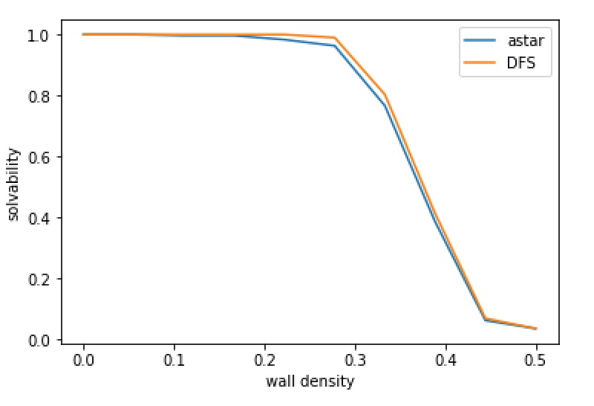

Figure 5.1 solvability modified A* vs DFS in fire maze problem

# 6. Contribution

X.WANG: 1,2,3, report writing

C.ZUO: 1,2,3,5

Haotian Xu: 1, 4, 5

# 7. Appendix

maze.py

#!/usr/bin/env python3

# -*- coding: utf-8 -*-

**import** structure

**import** numpy **as** np

**import** matplotlib**.**pyplot **as** plt

**import** random

**import** math

**from** datetime **import** datetime

e **=** math**.**e

ctr **=** 0

**def** manhattanDistance**(**state**,** goal**):**

**(**x1**,** y1**),** **(**x2**,** y2**)** **=** state**,** goal

**return** abs**(**x2 **-** x1**)** **+** abs**(**y2 **-** y1**)**

**def** euclideanDistance**(**state**,** goal**):**

**(**x1**,** y1**),** **(**x2**,** y2**)** **=** state**,** goal

**return** **((**x2 **-** x1**)** **\*\*** 2 **+** **(**y2 **-** y1**)** **\*\*** 2**)\*\***0.5

**class** **Maze:**

**def** __init__**(**self**,** length**,** width**,** initialP**):**

self**.**length **=** length

self**.**width **=** width

self**.**maze **=** **{}**

self**.**initialP **=** initialP

self**.**numerator **=** **-(**self**.**length **+** self**.**width**)**

self**.**denominator **=** length **\*** width **-**2

self**.**probability **=** initialP **\*** **(**e**)**(**self**.**numerator**/**self**.**denominator**)**

**for** i **in** range**(**length**):**

**for** j **in** range**(**width**):**

self**.**maze**[(**i**,** j**)]** **=** **-**1

self**.**start **=** **(**0**,** 0**)**

self**.**goal **=** **(**length **-** 1**,** width **-** 1**)**

**def** generateMaze**(**self**):**

'''

(x, y) -> 0 : empty

(x, y) -> 1 : obstruction

'''

**for** coordinates **in** self**.**maze**.**keys**():**

**if** coordinates **!=** self**.**start **and** coordinates **!=** self**.**goal**:**

p **=** random**.**random**()**

**if** p **<** self**.**probability**:**

self**.**maze**[**coordinates**]** **=** 1

self**.**denominator **-=** 1

**else:**

self**.**maze**[**coordinates**]** **=** 0

self**.**numerator **+=** 1

self**.**probability **=** self**.**initialP **\*** **(**e**)**(**self**.**numerator**/**self**.**denominator**)**

**def** printMaze**(**self**,** Search**,** heuristic **=** **None):**

path **=** self**.**getPath**(**Search**,** heuristic**)**

mazeMap **=** np**.**zeros**((**self**.**length**,** self**.**width**),** dtype **=** int**)**

**for** **(**x**,** y**)** **in** self**.**maze**.**keys**():**

mazeMap**[**x**,** y**]** **=** self**.**maze**[(**x**,** y**)]**

**for** **(**x**,** y**)** **in** path**:**

mazeMap**[**x**,** y**]** **=** **-**1

plt**.**figure**(**figsize**=(**5**,**5**))**

plt**.**pcolor**(**mazeMap**[::-**1**],**edgecolors**=**'black'**,**cmap**=**'Blues'**,** linewidths**=**2**)**

plt**.**xticks**([]),** plt**.**yticks**([])**

plt**.**tight_layout**()**

plt**.**show**()**

**def** isWall**(**self**,** state**):**

**return** self**.**maze**[**state**]** **==** 1

**def** getSuccessor**(**self**,** state**):**

'''input:

- state: a tuple stands for coordinates

output:

- a list of successor,

- a successor contains the neighbor's cooridinates and the action

for current state to go there, and the cost(distance) between

'''

successors **=** **[]**

**(**x**,** y**)** **=** state

**if** x **-** 1 **>=** 0 **and** **not** self**.**isWall**((**x **-** 1**,** y**)):**

successors**.**append**(((**x **-** 1**,** y**),** "west"**,** 1**))**

**if** y **-** 1 **>=** 0 **and** **not** self**.**isWall**((**x**,** y **-** 1**)):**

successors**.**append**(((**x**,** y **-** 1**),** "north"**,** 1**))**

**if** x **+** 1 **<** self**.**length **and** **not** self**.**isWall**((**x **+** 1**,** y**)):**

successors**.**append**(((**x **+** 1**,** y**),** "east"**,** 1**))**

**if** y **+** 1 **<** self**.**width **and** **not** self**.**isWall**((**x**,** y **+** 1**)):**

successors**.**append**(((**x**,** y **+** 1**),** "south"**,** 1**))**

**return** successors

**def** isGoalState**(**self**,** state**):**

'''

check if the current state is the goal state

'''

**return** state **==** self**.**goal

**def** getPath**(**self**,** Search**,** heuristic **=** **None):**

'''

Input: a search function, which may have heuristic function

Turning the series of actions into coordinates

Output: a list of states

'''

path **=** **[]**

**if** heuristic **==** **None:**

path **=** Search**(**self**)**

**else:**

path **=** Search**(**self**,** heuristic**)**

states **=** **[**self**.**start**]**

**for** action **in** path**:**

**(**x**,** y**)** **=** states**[-**1**]**

**if** action **==** "west"**:**

states**.**append**((**x **-** 1**,** y**))**

**elif** action **==** "north"**:**

states**.**append**((**x**,** y **-** 1**))**

**elif** action **==** "east"**:**

states**.**append**((**x **+** 1**,** y**))**

**elif** action **==** "south"**:**

states**.**append**((**x**,** y **+** 1**))**

**return** states

**def** simplify**(**self**,** fraction**):**

'''

input:

fraction: a number ∈ [0,1]

fraction == 1: empty maze

fraction == 0: no changes

output:

a copy of the maze, which strip out a fraction of the obstructions

'''

simple **=** Maze**(**self**.**length**,** self**.**width**,** 0**)**

simple**.**maze **=** self**.**maze**.**copy**()**

wallState **=** **[]**

numberOfWall **=** 0

**for** state **in** self**.**maze**.**keys**():**

**if** self**.**maze**[**state**]** **==** 1**:**

wallState**.**append**(**state**)**

numberOfWall **+=** 1

random**.**shuffle**(**wallState**)**

stripNumber **=** math**.**ceil**(**fraction **\*** numberOfWall**)**

**for** state **in** wallState**:**

simple**.**maze**[**state**]** **=** 0

stripNumber **-=** 1

**if** stripNumber **==** 0**:**

**break**

**return** simple

**class** **FireMaze(**Maze**):**

**def** __init__**(**self**,**length**,** width**,** initialP**,** fire**):**

'''

initialize the number of the fire spots

'''

Maze**.**__init__**(**self**,** length**,** width**,** initialP**)**

self**.**fire **=** fire

self**.**fireSpots **=** **[]**

self**.**probabilityDistribution **=** **{}**

**for** state **in** self**.**maze**.**keys**():**

self**.**probabilityDistribution**[**state**]** **=** 0

self**.**utility **=** **{}**

**def** setFire**(**self**):**

'''

randomly distribute the fire spots

'''

coordinates **=** **[]**

**for** x **in** range**((**self**.**length **//** 4**)** **+** 1**,** 3 **\*** self**.**length **//** 4**):**

**for** y **in** range**((**self**.**width **//** 4**)** **+** 1**,** 3 **\*** self**.**width **//** 4**):**

coordinates**.**append**((**x**,** y**))**

fire **=** self**.**fire

random**.**shuffle**(**coordinates**)**

**for** coordinate **in** coordinates**:**

self**.**maze**[**coordinate**]** **=** 2

self**.**probabilityDistribution**[**coordinate**]** **=** 1

self**.**fireSpots**.**append**(**coordinate**)**

fire **-=** 1

**if** fire **==** 0**:**

**break**

**def** fireProbability**(**self**,** state**):**

'''

Input:

- a state coordinate

Output:

- a number between 0 ~ 1 indicates the probability of the state

changing to fire state

'''

**(**x**,** y**)** **=** state

**if** self**.**maze**[**state**]** **==** 2**:**

self**.**probabilityDistribution**[**state**]** **=** 1

**if** state **not** **in** self**.**fireSpots**:**

self**.**fireSpots**.**append**(**state**)**

**return** 1

'''

probFire = 0

if x - 1 >= 0:

probFire += self.probabilityDistribution[(x - 1, y)]

if y - 1 >= 0:

probFire += self.probabilityDistribution[(x, y - 1)]

if x + 1 < self.length:

probFire += self.probabilityDistribution[(x + 1, y)]

if y + 1 < self.width:

probFire += self.probabilityDistribution[(x, y + 1)]

return (0.25)**(probFire)

'''

distances **=** **[]**

**for** spot **in** self**.**fireSpots**:**

distances**.**append**(**manhattanDistance**(**spot**,** state**))**

distance **=** min**(**distances**)**

**return** 0.25 **\*\*** **(**distance**)**

**def** getNeighbor**(**self**,** state**):**

'''

Input: a given state with (x, y) as its coordinates

Output:

the neighborhoods in four directions(n, e, s, w)

'''

**(**x**,** y**)** **=** state

neighbor **=** **[]**

**if** x **-** 1 **>=** 0**:**

neighbor**.**append**((**x **-** 1**,** y**))**

**if** x **+** 1 **<** self**.**length**:**

neighbor**.**append**((**x **+** 1**,** y**))**

**if** y **-** 1 **>=** 0**:**

neighbor**.**append**((**x**,** y **-** 1**))**

**if** y **+** 1 **<** self**.**width**:**

neighbor**.**append**((**x**,** y **+** 1**))**

**return** neighbor

**def** distributeFire**(**self**):**

'''

Distribute the fire probability to whole maze

Using a dictionary to keep memorize the probability in each state

Update probability when we spread fire

'''

probabilityLevel **=** self**.**fireSpots**.**copy**()**

#print(probabilityLevel)

#return None

newProbability **=** **{}**

**for** state **in** self**.**fireSpots**:**

newProbability**[**state**]** **=** 1

#n = 10

**for** state **in** self**.**probabilityDistribution**.**keys**():**

**if** self**.**probabilityDistribution**[**state**]** **!=** 1**:**

self**.**probabilityDistribution**[**state**]** **=** 0

**while** len**(**newProbability**)** **<** len**(**self**.**probabilityDistribution**):**

amount **=** len**(**probabilityLevel**)**

**for** i **in** range**(**amount**):**

state **=** probabilityLevel**[**i**]**

#print('state:', state, 'neighbor:', self.getNeighbor(state))

#print('current state ', state, 'has probability', self.probabilityDistribution[state])

**for** neighbor **in** self**.**getNeighbor**(**state**):**

#print('neighbor', neighbor, 'has probability', self.probabilityDistribution[neighbor])

**if** self**.**probabilityDistribution**[**neighbor**]** **<** self**.**probabilityDistribution**[**state**]** **and** neighbor **not** **in** newProbability**.**keys**():**

newProbability**[**neighbor**]** **=** self**.**fireProbability**(**neighbor**)**

probabilityLevel**.**append**(**neighbor**)**

#print('changed neighbor:', neighbor,'now has probabilit', self.probabilityDistribution[neighbor] ,'but will have probability:', newProbability[neighbor])

**for** location **in** newProbability**.**keys**():**

self**.**probabilityDistribution**[**location**]** **=** newProbability**[**location**]**

probabilityLevel **=** probabilityLevel**[**amount**:]**

#print(self.probabilityDistribution)

**def** spreadFire**(**self**):**

'''

Spread fire from the fire spots

'''

#print(1)

#print(self.probabilityDistribution)

newSpots **=** **[]**

**for** state **in** self**.**fireSpots**:**

**for** neighbor **in** self**.**getNeighbor**(**state**):**

**if** neighbor **not** **in** self**.**fireSpots **and** random**.**random**()** **<=** self**.**probabilityDistribution**[**neighbor**]:**

self**.**probabilityDistribution**[**neighbor**]** **=** 1

**if** neighbor **not** **in** newSpots**:**

newSpots**.**append**(**neighbor**)**

self**.**fireSpots **+=** newSpots

#print(1)

#print(self.probabilityDistribution)

**def** DFS**(**maze**):**

'''

Using stack as the data structure

return when we pop the goal state

Output:

a series of actions

'''

stack **=** structure**.**Stack**()**

stack**.**push**((**maze**.**start**,** **[]))**

visited **=** **{}**

**global** ctr

ctr **=** 0

**while** **not** stack**.**isEmpty**():**

**(**state**,** path**)** **=** stack**.**pop**()**

ctr **+=** 1

**if** maze**.**isGoalState**(**state**):**

#print("Reach the goal!")

**return** path

**for** successor **in** maze**.**getSuccessor**(**state**):**

**(**neighbor**,** action**,** _**)** **=** successor

**if** neighbor **not** **in** visited**.**keys**():**

stack**.**push**((**neighbor**,** path **+** **[**action**]))**

**if** state **not** **in** visited**.**keys**():**

visited**[**state**]** **=** **True**

**if** stack**.**isEmpty**():**

#print("There is no such a path!")

**return** path

**def** BFS**(**maze**):**

'''

Using queue as the data structure

return when we meet the goal state

Output:

a series of actions

'''

queue **=** structure**.**Queue**()**

queue**.**enqueue**((**maze**.**start**,** **[]))**

visited **=** **{}**

**global** ctr

ctr **=** 0

**while** **not** queue**.**isEmpty**():**

**(**state**,** path**)** **=** queue**.**dequeue**()**

ctr **+=** 1

**for** successor **in** maze**.**getSuccessor**(**state**):**

**(**neighbor**,** action**,** _**)** **=** successor

**if** maze**.**isGoalState**(**neighbor**):**

#print("Reach the goal!")

**return** path **+** **[**action**]**

**elif** neighbor **not** **in** visited**.**keys**():**

queue**.**enqueue**((**neighbor**,** path **+** **[**action**]))**

**if** state **not** **in** visited**.**keys**():**

visited**[**state**]** **=** **True**

**if** queue**.**isEmpty**():**

#print("There is no such a path!")

**return** path

**def** Astar**(**maze**,** heuristic**):**

'''

input:

- heuristic : a function which gives us the estimated value

Using min-heap (priority queue) as data structure

return when we pop the goal state

Output:

a series of actions

'''

Heap **=** structure**.**PriorityQueue**()**

Heap**.**heap **=** **[(**0**,** 1**,** **(**maze**.**start**,** **[],** heuristic**(**maze**.**start**,** maze**.**goal**)))]**

visited **=** **{}**

**global** ctr

ctr **=** 0

**while** **not** Heap**.**isEmpty**():**

**(**state**,** path**,** priority**)** **=** Heap**.**pop**()**

ctr **+=** 1

**if** maze**.**isGoalState**(**state**):**

#print("Reach the goal!")

**return** path

**for** successor **in** maze**.**getSuccessor**(**state**):**

**(**neighbor**,** action**,** cost**)** **=** successor

**if** neighbor **not** **in** visited**.**keys**():**

visited**[**neighbor**[**0**]]** **=** **True**

Heap**.**update**((**neighbor**,** path **+** **[**action**],** priority **+** cost**),** priority **+** cost **+** heuristic**(**neighbor**,** maze**.**goal**))**

**if** state **not** **in** visited**.**keys**():**

visited**[**state**]** **=** **True**

**if** Heap**.**isEmpty**():**

#print("There is no such a path!")

**return** path

**def** approximateDistance**(**maze**):**

**return** len**(**BFS**(**maze**))**

**def** Astar_Thinning**(**maze**):**

Heap **=** structure**.**PriorityQueue**()**

Heap**.**heap **=** **[(**0**,** 1**,** **(**maze**.**start**,** **[],** approximateDistance**(**maze**)))]**

simple **=** maze**.**simplify**(**0.6**)**

simple**.**printMaze**(**Astar**,** manhattanDistance**)**

visited **=** **{}**

**while** **not** Heap**.**isEmpty**():**

**(**state**,** path**,** priority**)** **=** Heap**.**pop**()**

**if** maze**.**isGoalState**(**state**):**

#print("Reach the goal!")

**return** path

simple**.**start **=** state

**for** successor **in** maze**.**getSuccessor**(**state**):**

**(**neighbor**,** action**,** cost**)** **=** successor

**if** neighbor **not** **in** visited**.**keys**():**

visited**[**neighbor**[**0**]]** **=** **True**

Heap**.**update**((**neighbor**,** path **+** **[**action**],** priority **+** cost**),** priority **+** cost **+** approximateDistance**(**simple**))**

**if** state **not** **in** visited**.**keys**():**

visited**[**state**]** **=** **True**

**if** Heap**.**isEmpty**():**

#print("There is no such a path!")

**return** path

**def** expectValue**(**fireMaze**,** state**,** visited**):**

'''

Input:

fireMaze: a fireMaze object

state: current state, determinate the probability of being fire in

the future (utility)

visited: a list of the nodes(states) which have already been expand

check the (current) state's utility by calculating its probability of being

fire in the future. Calculation is based on the utility of its neighborhoods

which means the probability of being fire is cumulative from the nearest fire spot

Output:

the utility of current state

'''

**if** fireMaze**.**isGoalState**(**state**):**

fireMaze**.**utility**[**state**]** **=** **(**fireMaze**.**length **+** fireMaze**.**width**)** **\*\*** 2

**return** **(**fireMaze**.**length **+** fireMaze**.**width**)** **\*\*** 2

**elif** fireMaze**.**probabilityDistribution**[**state**]** **==** 1**:**

fireMaze**.**utility**[**state**]** **=** **-**10

**return** **-**10

value **=** 0

**for** successor **in** fireMaze**.**getSuccessor**(**state**):**

**(**neighbor**,** _**,** _**)** **=** successor

**if** neighbor **not** **in** visited**:**

probability **=** fireMaze**.**probabilityDistribution**[**neighbor**]**

**if** neighbor **not** **in** fireMaze**.**utility**.**keys**():**

fireMaze**.**utility**[**neighbor**]** **=** expectValue**(**fireMaze**,** neighbor**,** visited**)**

value **+=** probability **\*** fireMaze**.**utility**[**neighbor**]**

fireMaze**.**utility**[**state**]** **=** value

**return** value

**def** FireBFS**(**fireMaze**,** state**):**

queue **=** structure**.**Queue**()**

queue**.**enqueue**((**state**,** **[]))**

visited **=** **{}**

states **=** **[**state**]**

**while** **not** queue**.**isEmpty**():**

**(**state**,** path**)** **=** queue**.**dequeue**()**

**for** successor **in** fireMaze**.**getSuccessor**(**state**):**

**(**neighbor**,** action**,** _**)** **=** successor

**if** fireMaze**.**isGoalState**(**neighbor**)** **or** neighbor **in** fireMaze**.**fireSpots**:**

#print("Reach the goal!")

path**.**append**(**action**)**

utility **=** 1

**for** action **in** path**:**

**(**x**,** y**)** **=** states**[-**1**]**

**if** action **==** "west"**:**

states**.**append**((**x **-** 1**,** y**))**

utility **\*=** fireMaze**.**probabilityDistribution**[(**x **-** 1**,** y**)]**

**elif** action **==** "north"**:**

states**.**append**((**x**,** y **-** 1**))**

utility **\*=** fireMaze**.**probabilityDistribution**[(**x**,** y **-** 1**)]**

**elif** action **==** "east"**:**

states**.**append**((**x **+** 1**,** y**))**

utility **\*=** fireMaze**.**probabilityDistribution**[(**x **+** 1**,** y**)]**

**elif** action **==** "south"**:**

utility **\*=** fireMaze**.**probabilityDistribution**[(**x**,** y **+** 1**)]**

**if** states**[-**1**]** **in** fireMaze**.**fireSpots**:**

utility **\*=** **(-**100**)**

**print(**utility**)**

**else:**

utility **=** **(**fireMaze**.**length **+** fireMaze**.**width**)** **\*\*** 2

**return** utility

**elif** neighbor **not** **in** visited**.**keys**():**

queue**.**enqueue**((**neighbor**,** path **+** **[**action**]))**

**if** state **not** **in** visited**.**keys**():**

visited**[**state**]** **=** **True**

**if** queue**.**isEmpty**():**

#print("There is no such a path!")

utility **=** 1

**for** action **in** path**:**

**(**x**,** y**)** **=** states**[-**1**]**

**if** action **==** "west"**:**

states**.**append**((**x **-** 1**,** y**))**

utility **\*=** fireMaze**.**probabilityDistribution**[(**x **-** 1**,** y**)]**

**elif** action **==** "north"**:**

states**.**append**((**x**,** y **-** 1**))**

utility **\*=** fireMaze**.**probabilityDistribution**[(**x**,** y **-** 1**)]**

**elif** action **==** "east"**:**

states**.**append**((**x **+** 1**,** y**))**

utility **\*=** fireMaze**.**probabilityDistribution**[(**x **+** 1**,** y**)]**

**elif** action **==** "south"**:**

utility **\*=** fireMaze**.**probabilityDistribution**[(**x**,** y **+** 1**)]**

**if** states**[-**1**]** **in** fireMaze**.**fireSpots**:**

utility **\*=** **(-**100**)**

**else:**

utility **=** utility **/** fireMaze**.**probabilityDistribution**[**states**[-**1**]]**

utility **\*=** **(**fireMaze**.**length **+** fireMaze**.**width**)** **\*\*** 2

**return** utility

**def** makeDecision**(**fireMaze**):**

visited **=** **[**fireMaze**.**start**]**

path **=** **[]**

**while** **True:**

state **=** visited**[-**1**]**

v **=** **-**2 **\*\*** 64

**print(**'number of fire spots:'**,** len**(**fireMaze**.**fireSpots**))**

**print(**'---------'**)**

**print(**fireMaze**.**fireSpots**)**

**print(**'---------'**)**

**print(**'current state is'**,** state**,** 'the probability of being fire is'**,** fireMaze**.**probabilityDistribution**[**state**])**

**if** fireMaze**.**isGoalState**(**state**):**

**print(**"You escape the fire maze!"**)**

**return** path

**elif** state **in** fireMaze**.**fireSpots**:**

**print(**"You are burned"**)**

**return** path

optimalAction **=** ''

nextState **=** state

**for** successor **in** fireMaze**.**getSuccessor**(**state**):**

**(**neighbor**,** action**,** _**)** **=** successor

**if** neighbor **not** **in** visited **and** v **<** FireBFS**(**fireMaze**,** neighbor**):**

v **=** FireBFS**(**fireMaze**,** neighbor**)**

nextState **=** neighbor

optimalAction **=** action

**print(**v**)**

visited**.**append**(**nextState**)**

path**.**append**(**optimalAction**)**

fireMaze**.**spreadFire**()**

fireMaze**.**distributeFire**()**

**def** maxValue**(**fireMaze**):**

'''

go through the whole maze, when moving to a state, the maze will update

its fire probability distribution, and based on the new distribution

function will choose the optimal direction

'''

visited **=** **[**fireMaze**.**start**]**

path **=** **[]**

**while** visited **!=** **[]:**

fireMaze**.**utility **=** **{}**

state **=** visited**[-**1**]**

nextState **=** state

optimalAction **=** ''

**if** fireMaze**.**isGoalState**(**state**):**

**return** path

value **=** **-**2 **\*\*** 64

**print(**1**)**

**for** successor **in** fireMaze**.**getSuccessor**(**state**):**

**(**neighbor**,** action**,** _**)** **=** successor

**print(**'state '**,** neighbor**,** 'with utility'**,** expectValue**(**fireMaze**,** neighbor**,** visited**))**

**if** neighbor **not** **in** visited **and** value **<** expectValue**(**fireMaze**,** neighbor**,** visited**):**

value **=** expectValue**(**fireMaze**,** neighbor**,** visited**)**

nextState **=** neighbor

optimalAction **=** action

**print(**fireMaze**.**utility**)**

**return** path

**if** nextState **!=** state**:**

**print(**'current state is '**,** state**)**

**print(**'next state will be'**,** nextState**,** ', and the action will be'**,** optimalAction**)**

visited**.**append**(**nextState**)**

visited **=** visited**[**1**:]**

**if** optimalAction **!=** ''**:**

path**.**append**(**optimalAction**)**

fireMaze**.**spreadFire**()**

fireMaze**.**distributeFire**()**

**return** path

**return** path

maze **=** Maze**(**10**,** 10**,** 0.2**)**

maze**.**generateMaze**()**

path **=** **[]**

ctr **=** 0

timeA **=** datetime**.**now**()**

maze**.**printMaze**(**BFS**)**

**print(**"operations of BFS is:"**,** ctr**)**

timeB **=** datetime**.**now**()**

maze**.**printMaze**(**DFS**)**

**print(**"operations of DFS is:"**,** ctr**)**

timeC **=** datetime**.**now**()**

maze**.**printMaze**(**Astar**,** manhattanDistance**)**

**print(**"operations of Astar-manhattan is:"**,** ctr**)**

timeD **=** datetime**.**now**()**

maze**.**printMaze**(**Astar**,** euclideanDistance**)**

**print(**"operations of Astar-Euclidean is:"**,** ctr**)**

timeE **=** datetime**.**now**()**

maze**.**printMaze**(**Astar_Thinning**)**

timeF **=** datetime**.**now**()**

**print(**"Running time of BFS:"**,**timeB**-**timeA**)**

**print(**"Running time of DFS:"**,**timeC**-**timeB**)**

**print(**"Running time of Astar-Manhattan:"**,**timeD**-**timeC**)**

**print(**"Running time of Astar-Euclidean:"**,**timeE**-**timeD**)**

**print(**"Running time of Astar-Thinning:"**,**timeF**-**timeE**)**

firemaze **=** FireMaze**(**10**,** 10**,** 0**,** 1**)**

firemaze**.**setFire**()**

firemaze**.**distributeFire**()**

**print(**makeDecision**(**firemaze**))**

structure.py

#!/usr/bin/env python3

# -*- coding: utf-8 -*-

**import** heapq

**class** **Stack:**

**def** __init__**(**self**):**

self**.**list **=** **[]**

**def** push**(**self**,** item**):**

self**.**list**.**append**(**item**)**

**def** pop**(**self**):**

**return** self**.**list**.**pop**()**

**def** isEmpty**(**self**):**

**return** self**.**list **==** **[]**

**class** **Queue:**

**def** __init__**(**self**):**

self**.**list **=** **[]**

**def** enqueue**(**self**,** item**):**

self**.**list**.**insert**(**0**,** item**)**

**def** dequeue**(**self**):**

**return** self**.**list**.**pop**()**

**def** isEmpty**(**self**):**

**return** self**.**list **==** **[]**

**class** **PriorityQueue:**

**def** __init__**(**self**):**

self.heap = []

self.count = 0

def push(self, item, priority):

entry = (priority, self.count, item)

heapq.heappush(self.heap, entry)

self.count += 1

def pop(self):

(_, _, item) = heapq.heappop(self.heap)

return item

def isEmpty(self):

return len(self.heap) == 0

def update(self, item, priority):

# If item already in priority queue with higher priority, update its priority and rebuild the heap.

# If item already in priority queue with equal or lower priority, do nothing.

# If item not in priority queue, do the same thing as self.push.

for index, (p, c, i) in enumerate(self.heap):

if i == item:

if p <= priority:

break

del self.heap[index]

self.heap.append((priority, c, item))

heapq.heapify(self.heap)

break

else:

self.push(item, priority)